Chapter 9, Problem 51.

If the voltage v_{o} across the 2-Ω resistor in the circuit of Fig. 9.58 is 10 cos(2t) V, obtain i_{s}.

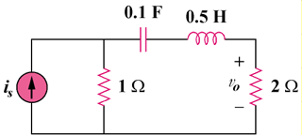

Figure 9.58
For Prob. 9.51.

